Lesson 09 – Introduction to Web API

1. If you have not completed the project setup, please perform project setup following instructions in **C286 L09 Project Setup.docx** first.
2. Open **Task List** window from the menu **VIEW**, **Task List**. Use the **Filter** function in the Project heading to display only the Task for Lesson09.
3. Download and install the 64-bit software “Postman” from this link:

<https://www.getpostman.com/downloads/>

We will use this software to test various API urls during the lesson.

1. **Activity 1:**
   * + 1. ***Add a new web api controller:*** In solution explorer, right-click on **Controllers** to add a new item. In the **Add New Item** dialog box, select **ASP.NET > API Controller Class with read/write actions**, leave the default name as **ValuesController.cs** and click on the **[Add]** button.

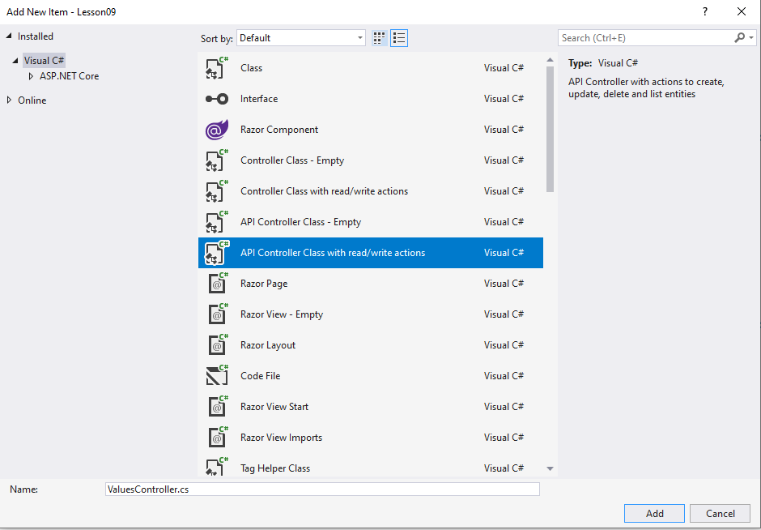

* + - 1. ***Configure the basic routing:*** Modify the basic routing template of **ValuesController**  as below

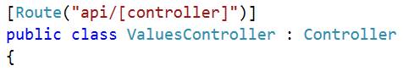 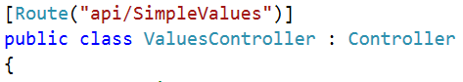

change **[controller]** to **SimpleValues**

* + - 1. Run the application in Chrome and navigate to [**http://localhost:xxxxx/api/SimpleValues**](http://localhost:xxxxx/api/SimpleValues)

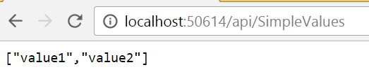

Note: You can use Internext Explorer. But the JSON output will be downloaded as a file instead. Using Chrome is recommended as it is easier to view the content of the JSON format returned

Using Postman:

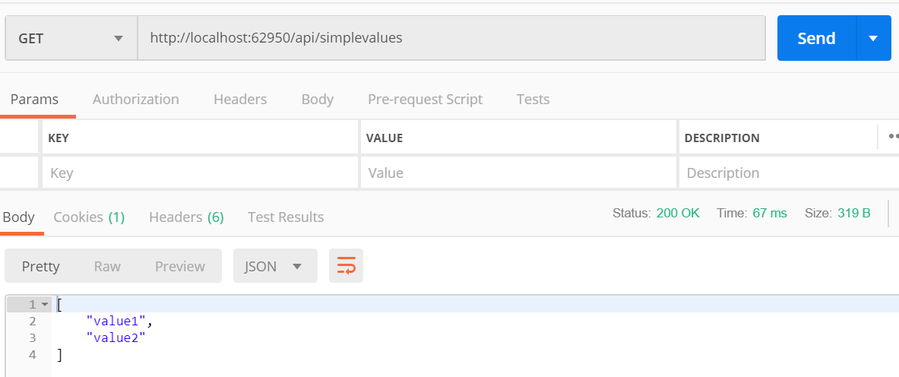

* + - 1. Which action is triggered by **api/SimpleValues**?
      2. Navigate to [**http://localhost:xxxxx/api/SimpleValues/5**](http://localhost:xxxxx/api/SimpleValues/5)**:**

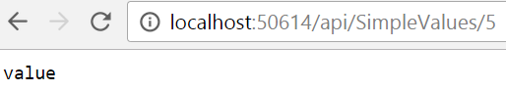

Postman:

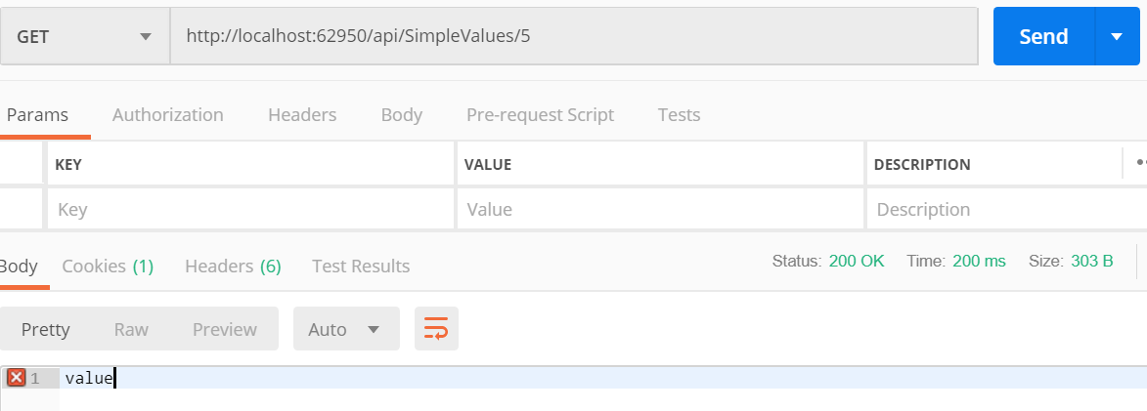

* + - 1. Which action is triggered by **api/SimpleValues/5**?
      2. Modify the **ValuesController** to achieve the following result:
         1. [**http://localhost:xxxxx/api/SimpleValues**](http://localhost:xxxxx/api/SimpleValues)

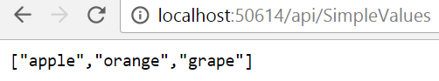

Postman:

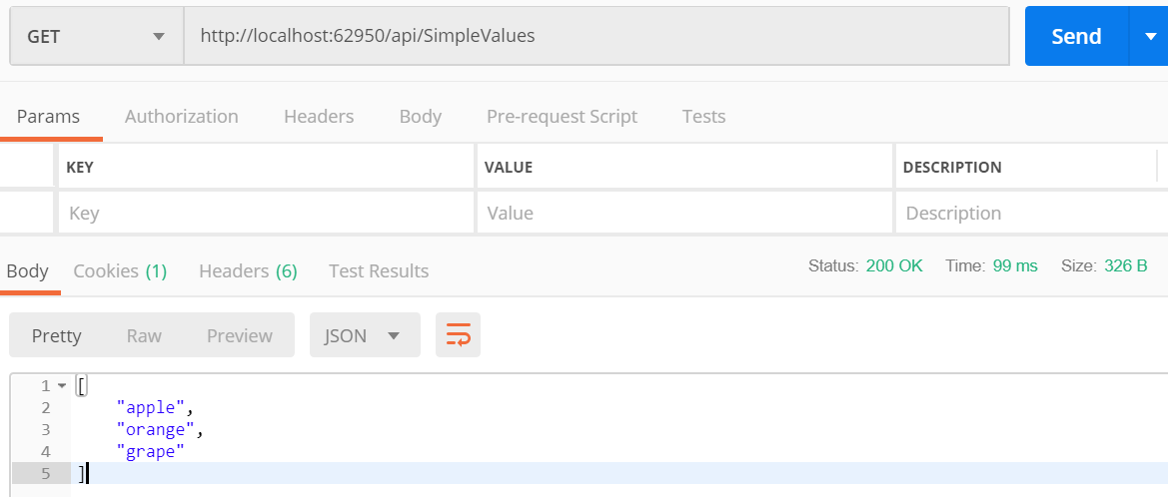

* + - * 1. [**http://localhost:xxxxx/api/SimpleValues/0**](http://localhost:xxxxx/api/SimpleValues/0)

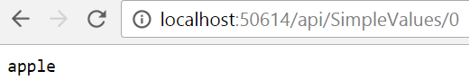

Postman:

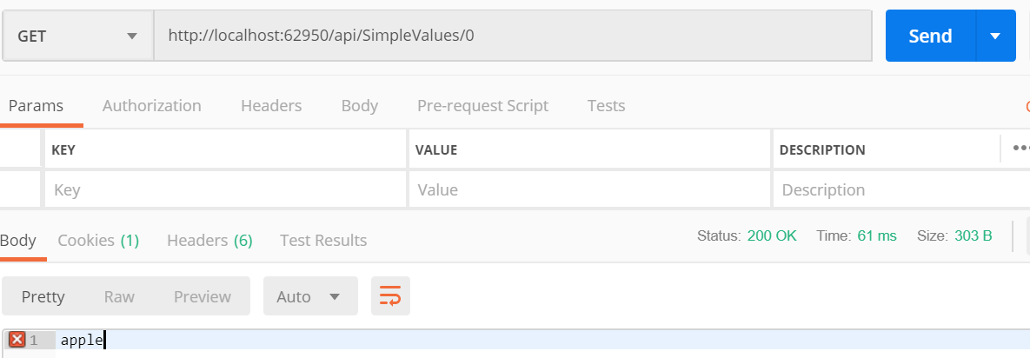

* + - * 1. [**http://localhost:xxxxx/api/SimpleValues/1**](http://localhost:xxxxx/api/SimpleValues/1)

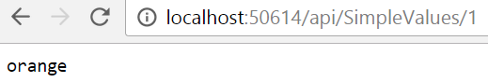

Postman:

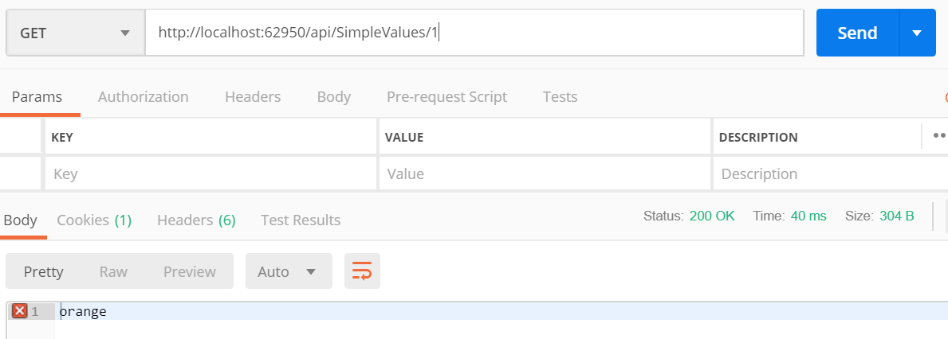

* + - * 1. [**http://localhost:xxxxx/api/SimpleValues/2**](http://localhost:xxxxx/api/SimpleValues/2)

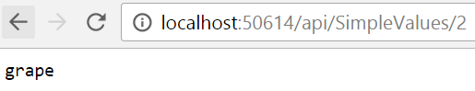

Postman:

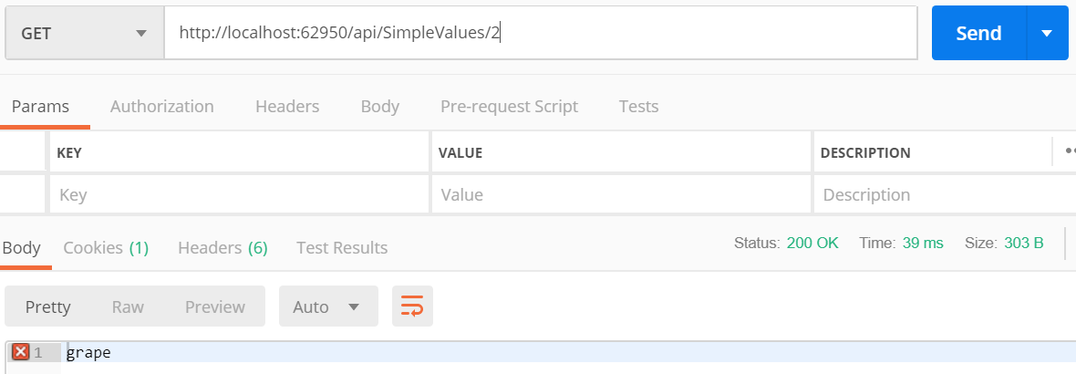

* + - 1. Copy your modified Web API actions to here:

private string[] fruits = {“apple”,”orange”,”grape”};

[HttpGet]

Public IEnumerable<string> Get()

{

Return fruits;

}

[HttpGet]

public string Get(int id)

{

Return fruits[id];

}

1. **Activity 2:**
   * + 1. Perform tasks 2-1 to 2-2.
       2. Refer to the 6P Part 1 slides to help you complete the task.
       3. Use browser, Chrome preferred, to test the various web api actions, use screenshots captured below as reference:
          1. GetAll action

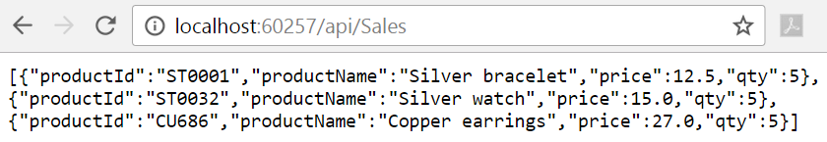

* + - * 1. Get action

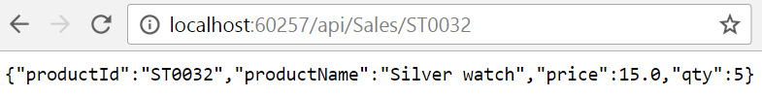

Postman:

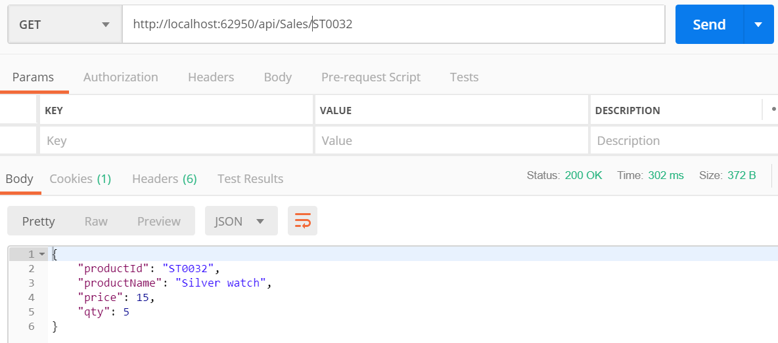

* + - * 1. GetPrice action

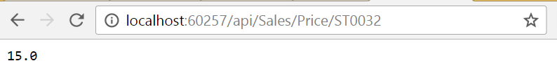

Postman:

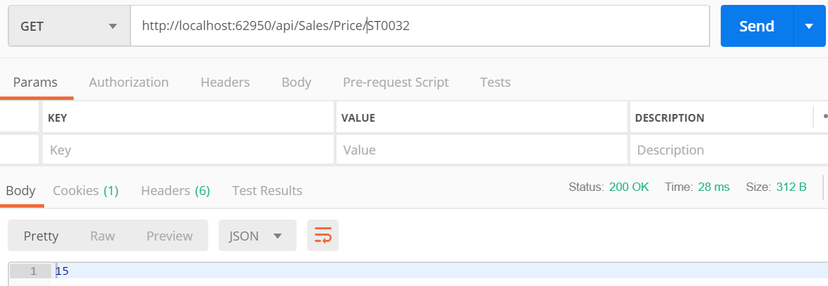

* + - * 1. GetName action

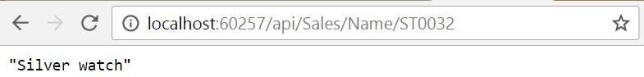

Postman:

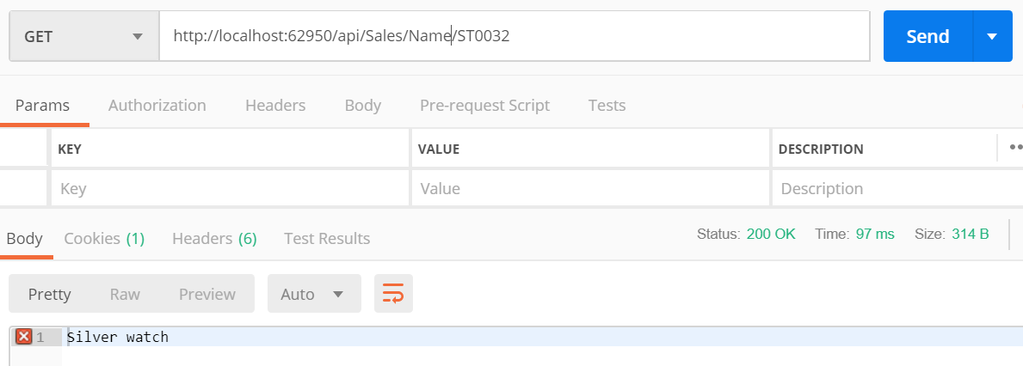

Note: Must ensure the string is enclosed within a pair of double quote "…"

1. **Activity 3:** 
   * + 1. Perform **Tasks 3-1 to 3-3**.
       2. **Tasks 3-1 to 3-3** are in Views/DemoAjax/Index.cshtml.
       3. Refer to the 6P Part 1 slides to help you complete the task.
       4. Run the application and navigate to this page.
       5. Check your answer with the lecturer.

# Solving the Problem

1. You can complete the problem by following the solution tasks in the project. You need to open RPNotes/Index.cshtml to see all soluton tasks.
2. Recommended order of implementation:
   1. Navigate to a specific lesson
      1. Web API action: **RPNotesApiController Get** action
      2. jQuery function to consume: **Views/RPNotes/Index.cshtml LoadNotes** function
      3. Refer to comments in code file for sample web requests and and responses
   2. Add new module
      1. Web API action **RPNotesApiController AddModule** action
      2. jQuery function to consume: **Views/RPNotes/Index.cshtml AddNewModule** function
      3. Refer to comments in code file for sample web requests and and responses
   3. Get all modules
      1. Partial View action: **RPNotesController GetModules** action
      2. jQuery function to consume: **Views/RPNotes/Index.cshtml LoadModules** function

# Testing Your Solution

1. Provide test cases here and screen shots to demonstrate that your web app is functioning well.

*— End of Worksheet —*